**National University of Computer and Emerging Sciences**



**Laboratory Manual**

*for*

# Data Structures Lab

|  |  |
| --- | --- |
| Course Instructor | Mr. Uzair Naqvi |
| Lab Instructor(s) | Seemab Ayub, Lubaina Zubair |
| Section | BCS-3H |
| Date | Wed, Dec 13, 2023 |
| Semester | Fall 2023 |

# Department of Computer Science

FAST-NU, Lahore, Pakistan

**Objectives:**

In this lab, students will practice:

1. Huffman

**Question 1: (On Paper)**

Huffman coding is a lossless data compression algorithm. The idea is to assign variable-length codes to input characters, the lengths of the assigned codes are based on the frequencies of corresponding characters. The most frequent character gets the smallest code and the least frequent character gets the largest code.

**Task-1:**

Write the Huffman code for each of the characters in this tree.

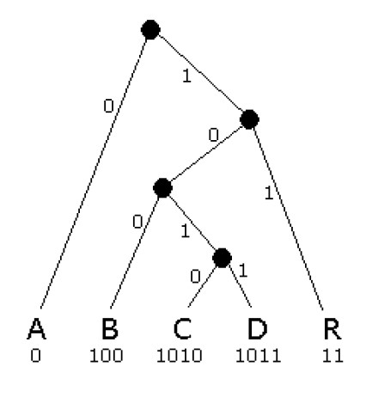

**Task-2:**

Write Huffman Code for the following text:

**Eerie eyes seen near lake.**

Show complete step-wise working; otherwise, the solutions will not be accepted.